Google News Personalization: Scalable Online
Collaborative Filtering

Introduction
Purpose
The purpose of this document is to present a detailed description of Google News Personalization: Scalable Online Collaborative Filtering. It will explain the purpose and features of the system, what the system will do, the constraints under which it must operate and how the system will react to external action.
Scope
Every user values his time and also appreciates better quality of service from every website he visits. No two users have similar tastes, for example when a user visits Google News he may only look at the technology section. Another user might prefer a broader spectrum of news. Here comes the need for personalization. With every article displayed not relevant to the user, the site would not be able to keep the user interested. On the other hand, if a user is presented with articles he likes, chances are that that person will be more likely to return to the site. This results in easy access of relevant articles to users and a higher hit rate for the site; which in turn can be of great value to the site(more advertisements, resulting in higher revenue).

Definitions
Term | Definition
Google News | Google News is an automated news aggregator provided by Google Inc. As a news aggregator site, Google uses its own software to determine which stories to show from the online news sources it watches. The stated information from Google is that it watches more than 4,500 English-language news sites.
Collaborative filtering | Collaborative filtering (CF) is a technique, popularized by Amazon and others, that uses user information such as ratings, clicks, and purchases to provide recommendations to other site users. CF is often used to recommend consumer items such as books, news, and movies, but it is also used in other applications where multiple actors need to collaborate to narrow down data.
Clustering | Given large data sets, whether they are text or numeric, it is often useful to group together, or cluster, similar items automatically. For instance, given all of the news for the day from all of the newspapers in the United States, you might want to group all of the articles about the same story together automatically; you can then choose to focus on specific clusters and stories without needing to wade through a lot of unrelated ones.

System Overview
This system aims to personalize Google News recommendations for each user. We generate recommendations using three approaches: collaborative ﬁltering using MinHash clustering, Probabilistic Latent Semantic Indexing (PLSI) and covisitation counts.

References
Research paper titled Google News Personalization: Scalable Online Collaborative Filtering by:

Abhinandan Das
Google Inc.
1600 Amphitheatre Pkwy,
Mountain View, CA 94043
abhinandan@google.com
Mayur Datar
Google Inc.
1600 Amphitheatre Pkwy,
Mountain View, CA 94043
mayur@google.com
Ashutosh Garg
Google Inc.
1600 Amphitheatre Pkwy,
Mountain View, CA 94043
ashutosh@google.com
Shyam Rajaram
University of Illinois at Urbana
Champaign
Urbana, IL 61801
rajaram1@ifp.uiuc.edu

Overall Description
System Environment
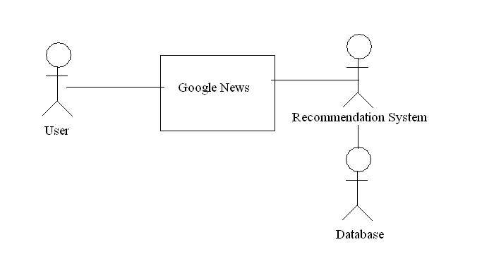
Figure 1 - System Overview
The software system has 3 actors the User, the Recommendation System and the Database consisting of all the Google News articles. The User browses the site and the Recommendation System provides the User with articles from the Database that he/she may be interested in.

Functional Requirements Specification
This section outlines the use cases for each of the active users separately.
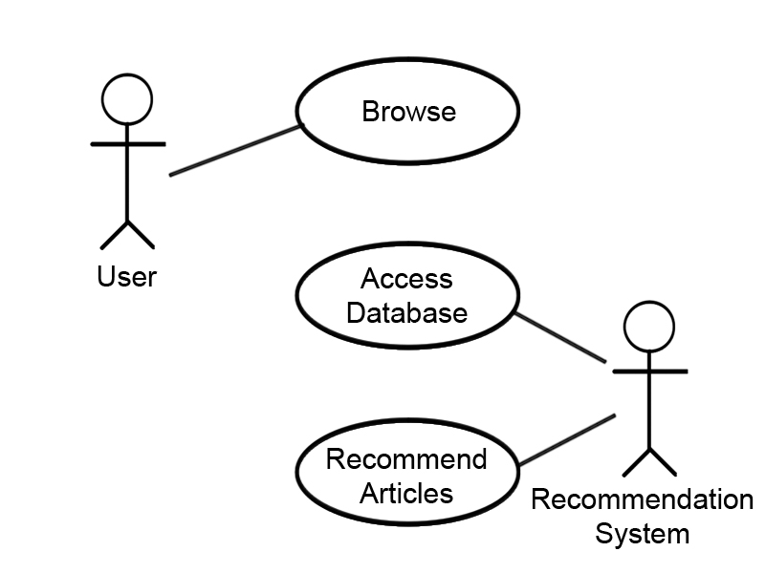
Figure 2 – Use Case Diagram
User Use Cases
- Browse: The User browses the site and selects an article which interests him/her.

Recommendation System Use Cases
- Access Database: The Recommendation System accesses the database for articles to recommend to the User.
- Recommend Articles: The Recommendation System provides the User with recommended articles.

User Characteristics
All users are expected to be computer literate. They should have the ability to understand and use Google News.
Non Functional Requirements
Internet connectivity is required at all times for the User to browse relevant data. A database on a highly replicated cluster is required to store all the articles.
Design Constraints
The main design constraint on the system is the requirement of a high performance Internet connection for access to Google News and the functioning of the cluster.

Design

Input

We have a Reuter’s data set consisting of 21578 articles. A UserID is associated to each article. These articles are categorized on the basis of different news genres.

Calculations
Describe user: Fabricated Click History of n users

We have n users. Every time a user clicks on a story, the news story clicked and the timestamp. This would aim to simulate a request to a webserver. These details are stored on a distributed file system (HDFS).
Algorithms used to generate cluster and build recommendation
MinHash
MinHashing is a probabilistic clustering method that assigns a pair of users to the same cluster with probability proportional to the overlap between the set of items that these users have voted for (clicked-on).
Covisitation
Our item based technique for generating recommendations makes use of covisitation instances, where covisitation is defined as an event in which two stories are clicked by the same user within a certain time interval (typically set to a few hours). Imagine a graph whose nodes represent items (news stories) and weighted edges represent the time discounted number of covisitation instances.
Twitter Search
We will use worldwide Twitter Trends to boost certain news articles.
Specific API Method: http://api.twitter.com/1/trends/:woeid.format
Parameters
WOEID required

The Yahoo! Where On Earth ID (WOEID) of the location to return trending information for. Global information is available by using 1 as the WOEID. Example Values: 1

Output

The output would generate clusters. Each cluster would consist of a set of users with a similar click history. Recommendations would be made to each user within the cluster based on articles read by other users.
Software/Libraries used

Apache Mahout, Lucene, Hadoop, Hadoop distributed file system (HDFS).

